**How to create Web part page?**

**In Sharepoint 2010**

Click on site actions --> More Options --> click on Page on left navigation --> then click on Webpart page.

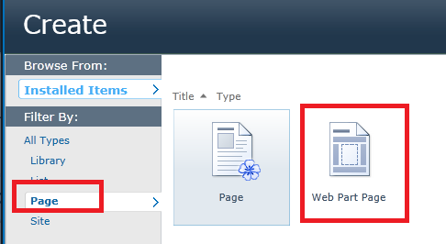

**In SharePoint 2013**

Click on All Site contents --> from Site Content page click on Site Page

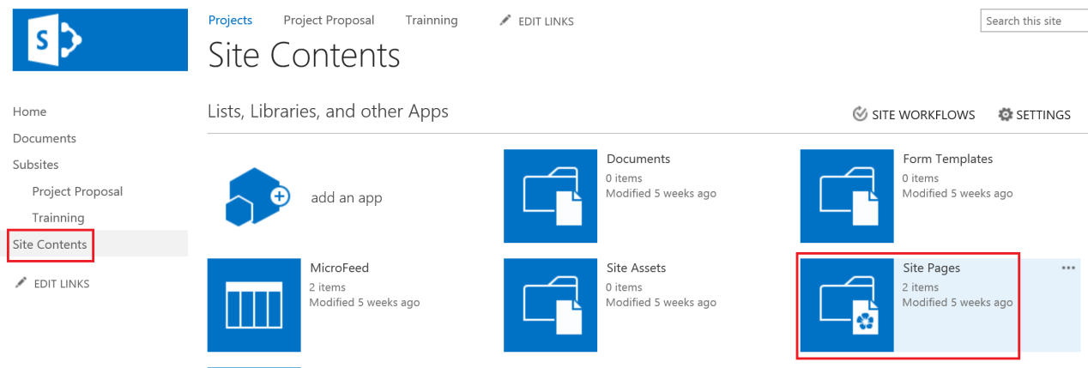

On Pages Page Click Files on the Ribbon

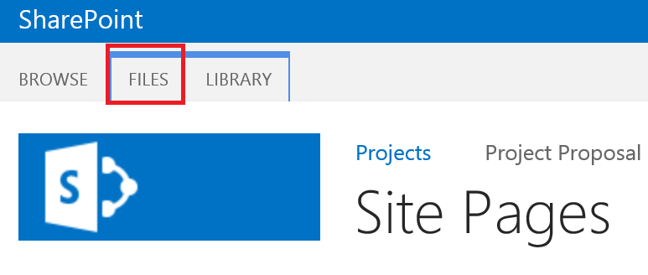

From the Files tab click on New Document

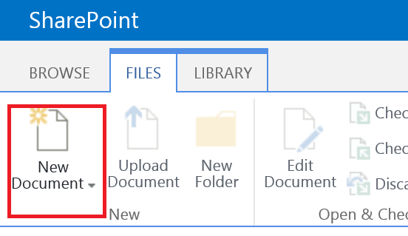

From new Document click on Wiki page or Web part Page

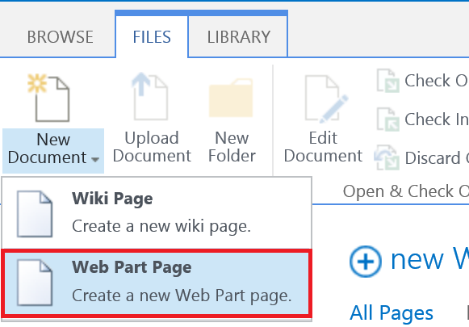

Finally we have Web part page

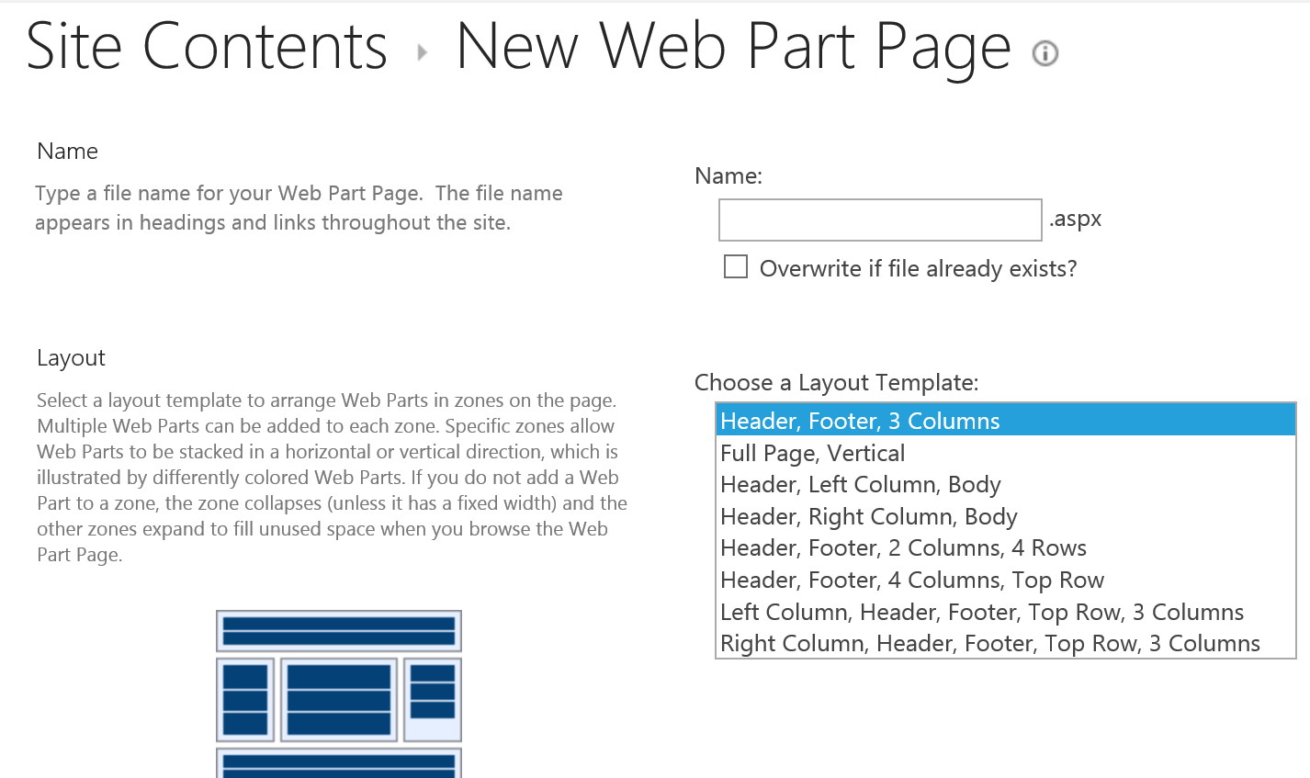

**Web Parts**

A Web Part is a modular unit of information that forms the basic building block of a Web Part Page. You can add Web Parts to Web Part zones in a Web Part Page and then customize the individual Web Parts to create a unique page for your site users.

The following example uses the Image Web Part to describe the basic features of a Web Part.

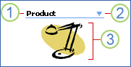

1. The Web Part title bar contains the heading for the Web Part.

2. The Web Part menu contains functions that enable you to minimize or close the Web Part, edit the Web Part, or get Help for a specific Web Part.

3. The body of the Web Part contains the content that you specified for the type of Web Part that is being used.

A Web Part Page is a special type of Web page in which you can use Web Parts to consolidate data, such as lists and charts, and Web content.

You can use a Web Part Page to do the following.

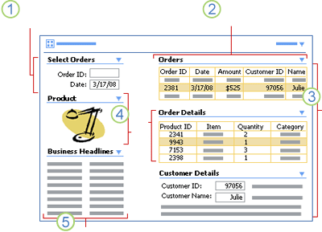

**Adding the Web Part to a page**

1. Navigate to the page where you want to install your Web part.

2. Click on Edit at the SharePoint 2013 site ribbon.

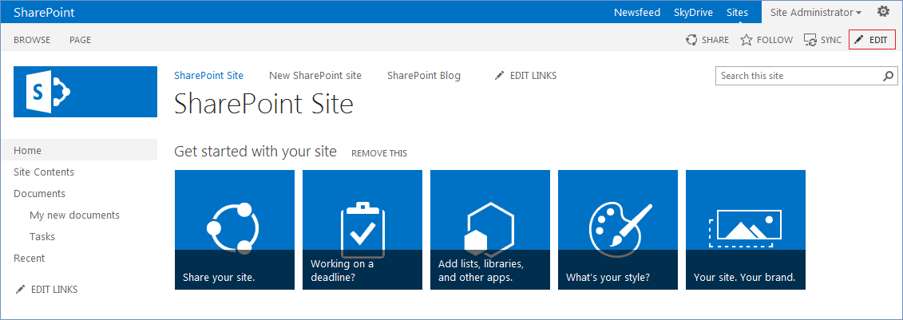

3. Choose the place where you wish to add your web part and in the Insert tab click on Web Part.

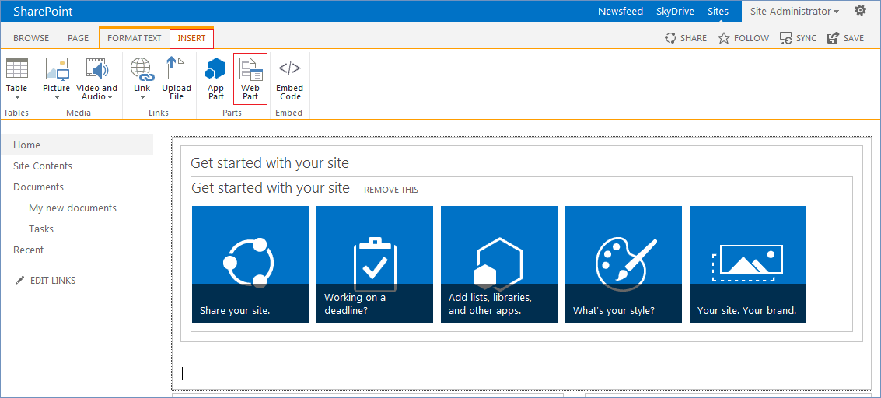

4. Select the uploaded web part from the list and click on Add.

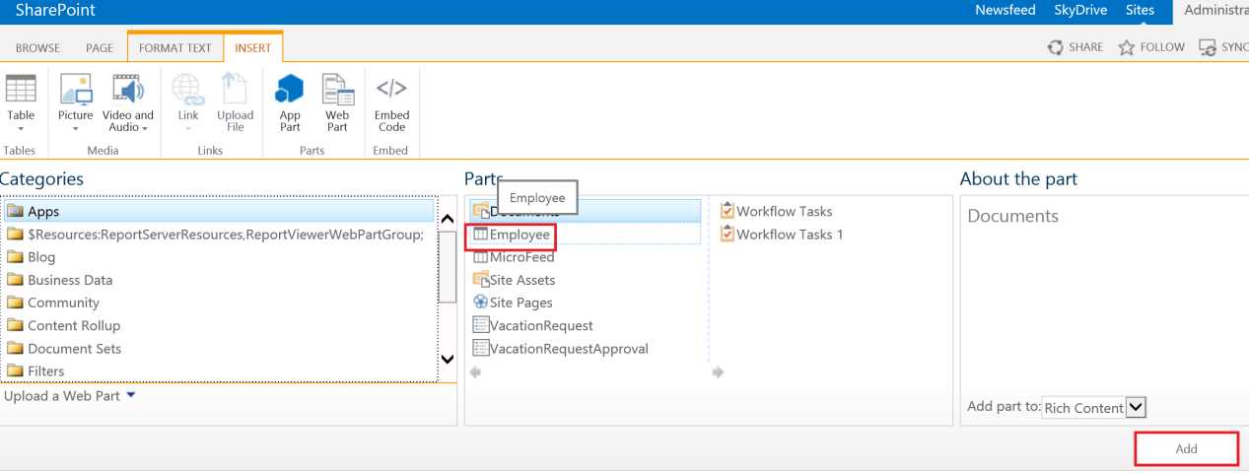

5. Click Save at the editing page.

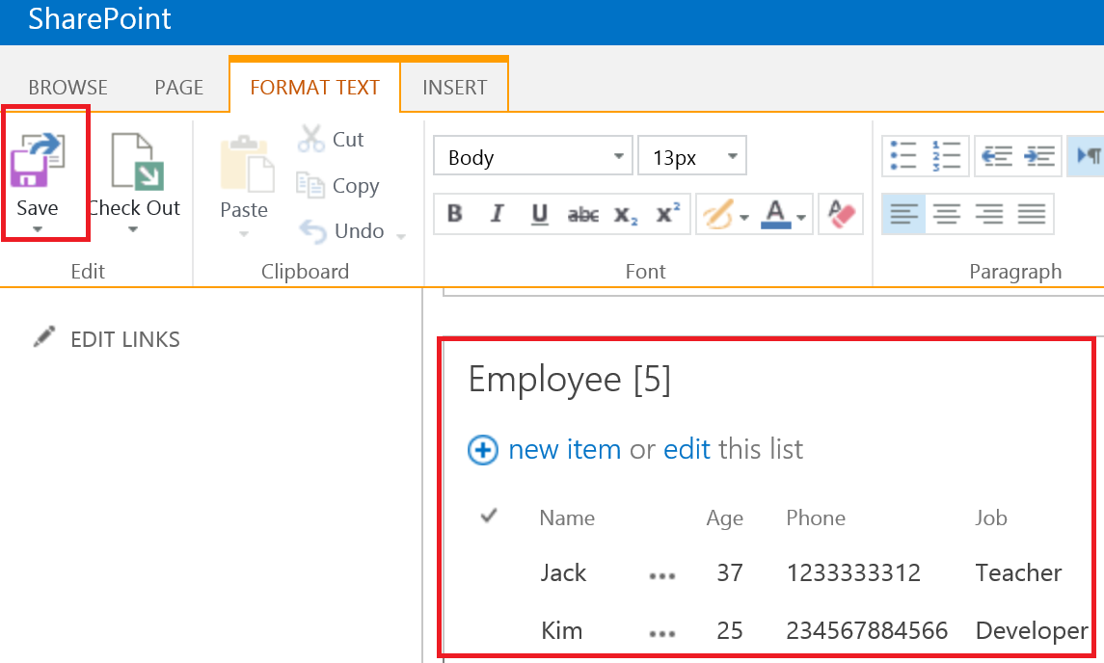

**Web Part pages**

The standard type of page in a site which started as a blank site. Allows the end user to put web parts in different zone, which makes them ideal for building "mashup" application, but hard to create ordinary content in.

**Wiki pages**

The standard type of pages in collaboration sites. Allows very easy editing of content and the mix-in of web parts when needed. Very good for unstructured content.

**Publishing pages**

The standard type of pages in publishing sites. The structure of the content is very much controlled by the page layouts, usually very limited use of web parts. Very good for making the site look consistent.